* Use different color highlighters to identify logos/ethos/pathos in the text.

COLOR KEY (Highlight each box):

LOGOS ETHOS PATHOS

----------------------------------------

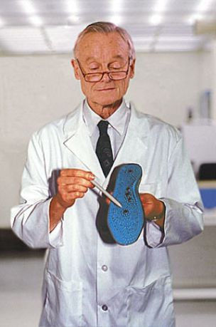
Revolutionary New Insoles Combine Five Forms Of Pseudoscience

MASSILLON, OH—Stressed and sore-footed Americans everywhere are clamoring for the exciting new MagnaSoles shoe inserts, which stimulate and soothe the wearer's feet using no fewer than five forms of pseudoscience.

The pseudoscientifically proven MagnaSoles.
"What makes MagnaSoles different from other insoles is the way it harnesses the power of magnetism to properly align the biomagnetic field around your foot," said Dr. Arthur Bluni, the pseudoscientist who developed the product for Massillon-based Integrated Products. "Its patented Magna-Grid design, which features more than 200 isometrically aligned Contour Points™, actually soothes while it heals, restoring the foot's natural bio-flow."

"MagnaSoles is not just a shoe insert," Bluni continued, "it's a total foot-rejuvenation system."
According to scientific-sounding literature trumpeting the new insoles, the Contour Points™ also take advantage of the semi-plausible medical technique known as reflexology. Practiced in the Occident for over 11 years, reflexology, the literature explains, establishes a correspondence between every point on the human foot and another part of the body, enabling your soles to heal your entire body as you walk.

Noted biotrician Dr. Wayne Frankel points out some of the unique properties of MagnaSoles.
But while other insoles have used magnets and reflexology as keys to their appearance of usefulness, MagnaSoles go several steps further.

According to the product's website, "Only MagnaSoles utilize the healing power of crystals to re-stimulate dead
NAME: ____________________________________

DATE: ____________________________

PERIOD: ________

foot cells with vibrational biofeedback... a process similar to that by which medicine makes people better."
In addition, MagnaSoles employ a brand-new, cutting-edge form of pseudoscience known as Terranometry, developed specially for Integrated Products by some of the nation's top pseudoscientists.

"The principles of Terranometry state that the Earth resonates on a very precise frequency, which it imparts to the surfaces it touches," said Dr. Wayne Frankel, the California State University biotrician who discovered Terranometry. "If the frequency of one's foot is out of alignment with the Earth, the entire body will suffer. Special resonator nodules implanted at key spots in MagnaSoles convert the wearer's own energy to match the Earth's natural vibrational rate of 32.805 kilofrankels. The resultant harmonic energy field rearranges the foot's naturally occurring atoms, converting the pain-nuclei into pleasing comfortrons."

Released less than a week ago, the $19.95 insoles are already proving popular among consumers, who are hailing them as a welcome alternative to expensive, effective forms of traditional medicine.
"I twisted my ankle something awful a few months ago, and the pain was so bad, I could barely walk a single step," said Helene Kuhn of Edison, NJ. "But after wearing MagnaSoles for seven weeks, I've noticed a significant decrease in pain and can now walk comfortably. Just try to prove that MagnaSoles didn't heal me!"

Equally impressed was chronic back-pain sufferer Geoff DeAngelis of Tacoma, WA.

"Why should I pay thousands of dollars to have my spine realigned with physical therapy when I can pay $20 for insoles clearly endorsed by an intelligent-looking man in a white lab coat?" DeAngelis asked. "MagnaSoles really seem like they're working."

----------------------------------------

ASSIGNMENT:

On the back, write one paragraph analyzing how the article uses either logos, ethos, or pathos. Be sure to use textual evidence to support your answer.

